**APPENDIX 2**

**B1: ROUGH DESIGNS**

Here are some of the designs that was later modified and changed.

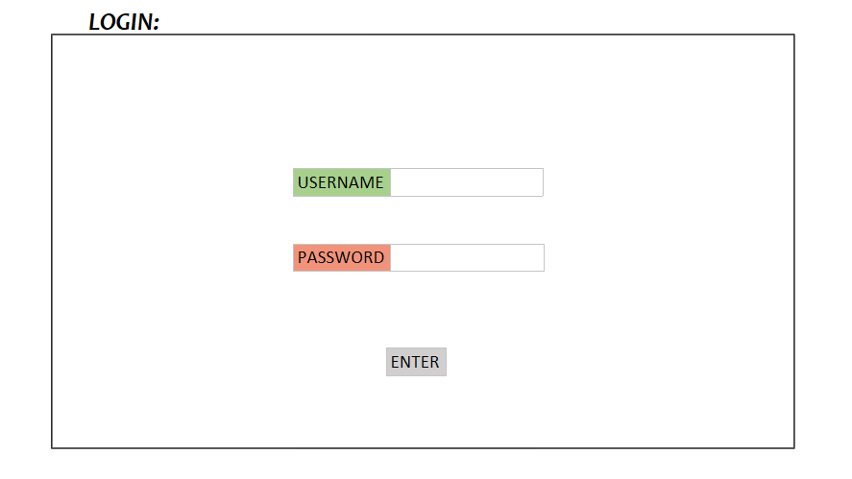

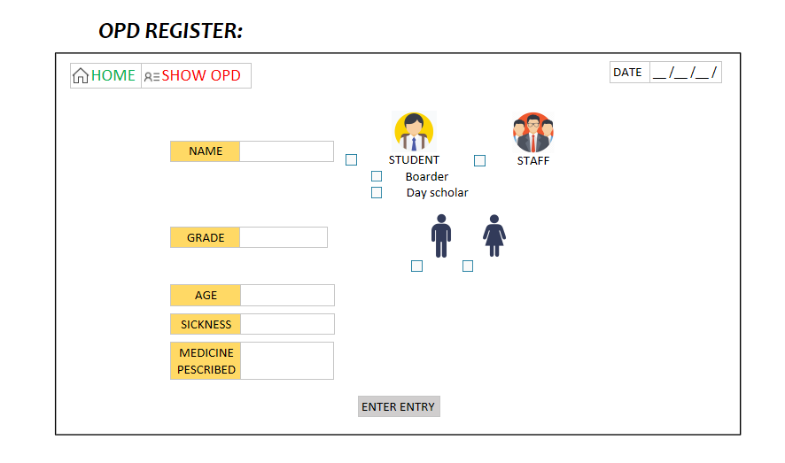

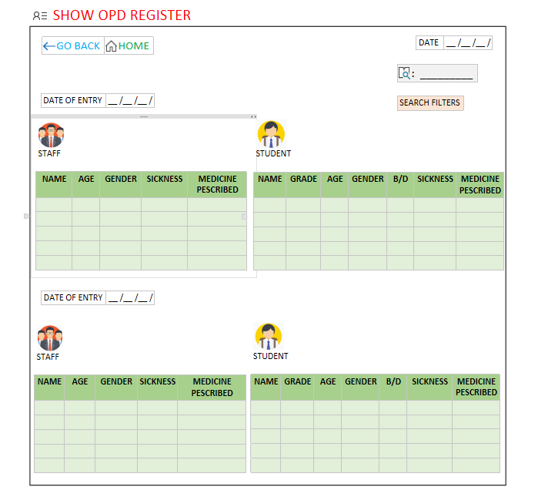

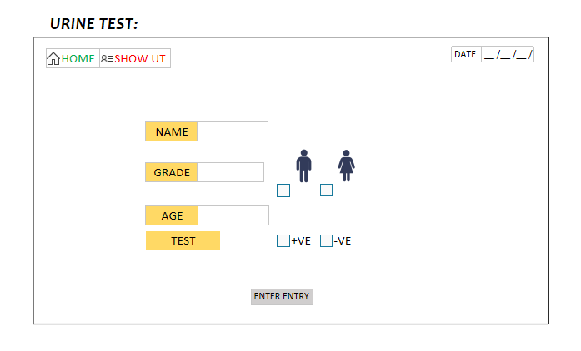

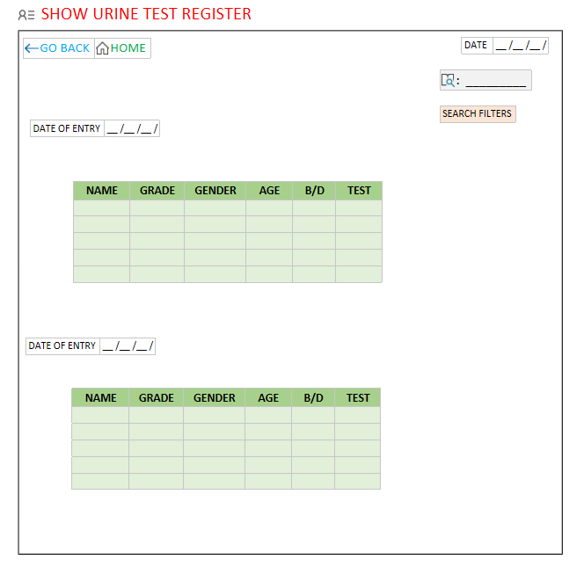

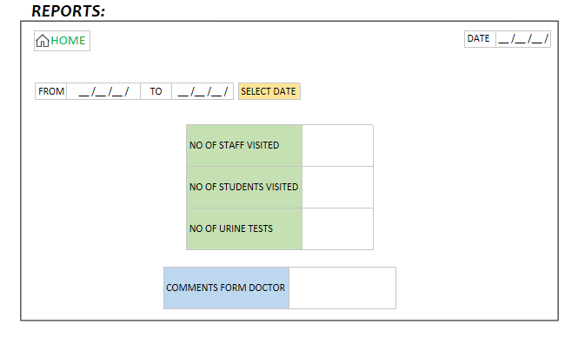

**B2: THE WEBSITE BEFORE MEETING WITH TEACHER**

NOTE the General Register is the OPD register. The name General register was later changed to OPD register.

|  |
| --- |
|  |
|  |
|  |
|  |
|  |
|  |

**B3: A MEETING WITH TEACHER**

I had a meeting with my teacher to show her the progress I had made and also ask for advice on how to proceed regarding the search functionality and get feedback.

Below is the WebEx meeting link that my teacher forwarded to me.

|  |
| --- |
|  |

**B4: THE WEBSITE AFTER MEETING WITH TEACHER**

After the meeting with my teacher. She asked me to work on the ascetics of the website and add more complexities.

Here are the screen shorts of the website after the meeting with teacher.

|  |
| --- |
|  |
|  |
|  |
|  |
|  |
|  |
|  |

The website after this was slightly modified and given the current form.

**B5: INSTALLING PROTOTYPE ON CLIENTS COMPUTER**

I had tried to get a prototype of the website on client’s computer but unfortunately it did not work out as planned. It was mostly due to the fact that we were trying to do it virtually due to the pandemic.

I had sent the following email with the link to the meeting.

|  |
| --- |
|  |

I had then sent an email with the files that needed to be downloaded.

|  |
| --- |
|  |

There were some issues for downloading the libraries like fontawesome and TCPDF from the google drive. So, I sent my client the actual website links to those two libraries.

|  |
| --- |
|  |
|  |

Despite these efforts I was not able to get a full working prototype on the clients computer for her to test however some of the functionalities did work and my client was happy with the progress nonetheless.

**B6: RANDOM DATA ENTRY GENERATOR**

My client said that on average the infirmary receives about 80 patients and sometimes even 150 patients (see appendix 1 A1 line 12). So, this means for around 2 years there will be 150*365*2≈100000 entries. To make sure there are no bugs when dealing with such large data sets, I created the following code to randomly generate entries.

|  |
| --- |
| RANDOM ENTRY GENERATOR FOR URINE TESTS |
| <?php  $Grade = array('6','7','8','9','10','11','12');    ?>  <?php  set_time_limit(5000);  date_default_timezone_set('Asia/Kolkata');  $Info=array('hostname'=>'localhost',  'username'=> 'root',  'password'=> '',  'dbname'=> 'Infirmary_Management');  $dbconn= mysqli_connect($Info['hostname'],  $Info['username'],  $Info['password'],  $Info['dbname']);  include("Datalist.php");  include("Names.php");  $CurDate=date("Y-m-d");  $CurTime=date("H:i");  function randomDate()  {  //$Y= rand(2019,2020);  $Y=2021;  $M= rand(00,12);  $D= rand(00,30);  $Date=$Y.'-'.$M.'-'.$D;  return $Date;  }  function randomTime()  {  $CurHr=intval(date("H"));  $CurMin=intval(date("i"));  $Time='';  $H= rand(00,24);  $Min= rand(00,60);  $S= rand(00,60);  if ($H<=$CurHr and $Min<=$CurMin) {  $Time=$H.':'.$Min.':'.$S;  }    return $Time;  }  function age($Grade)  {  if ($Grade=='NA')  $Age=rand(25,40);  if ($Grade=='6')  $Age=rand(11,13);  if ($Grade=='7')  $Age=rand(12,13);  if ($Grade=='8')  $Age=rand(13,14);  if ($Grade=='9')  $Age=rand(13,15);  if ($Grade=='10')  $Age=rand(14,16);  if ($Grade=='11')  $Age=rand(16,17);  if ($Grade=='12')  $Age=rand(16,18);  return $Age;  }  $ut=100000;  $uttoday=10;  if ($dbconn)  {  $Testresult=array('+','-');    $c1=0; $c2=0;  for ($i=0; $i<$ut ; $i++)  {  $Grade1=$Grade[rand(0,6)];  $Age1=age($Grade1);  $r=rand(0,100);  $Name1=$Name[$r][0];  $Gender1=$Name[$r][1];  $Testresult1=$Testresult[rand(0,1)];  $Date=randomDate();  $Time=randomTime();  $query= "INSERT INTO urine_test_register  (slno, name, grade, age, gender, testresult, entryDate, entryTime)  VALUE  (slno,'$Name1','$Grade1','$Age1','$Gender1','$Testresult1','$Date','$Time')";  $Q=mysqli_query($dbconn,$query);  if($Q)  $c1=1;  }  if($c1==1)  echo "UT Entry successul";  //Todays date  for ($i=0; $i <$uttoday ; $i++)  {  $Grade1=$Grade[rand(0,6)];  $Age1=age($Grade1);  $r=rand(0,67);  $Name1=$Name[$r][0];  $Gender1=$Name[$r][1];  $Testresult1=$Testresult[rand(0,1)];  $Date=randomDate();  $Time=randomTime();  $query= "INSERT INTO urine_test_register  (slno, name, grade, age, gender, testresult, entryDate, entryTime)  VALUE  (slno,'$Name1','$Grade1','$Age1','$Gender1','$Testresult1',CURDATE(),CURTIME())";  $Q=mysqli_query($dbconn,$query);  if($Q)  $c2=1;  }  if($c2==1)  echo "UT todays Entry successul";  }  ?> |

|  |
| --- |
| RANDOM ENTRY GENERATOR FOR OPD |
| <?php  $Grade = array('6','7','8','9','10','11','12','NA');    ?>  <?php  set_time_limit(5000);  date_default_timezone_set('Asia/Kolkata');  $Info=array('hostname'=>'localhost',  'username'=> 'root',  'password'=> '',  'dbname'=> 'Infirmary_Management');  $dbconn= mysqli_connect($Info['hostname'],  $Info['username'],  $Info['password'],  $Info['dbname']);  include("Datalist.php");  include("Names.php");  $CurDate=date("Y-m-d");  $CurTime=date("H:i");  function randomDate()  {  //$Y= rand(2019,2020);  $Y=2021;  $M= rand(00,12);  $D= rand(00,30);  $Date=$Y.'-'.$M.'-'.$D;  return $Date;  }  function randomTime()  {  $CurHr=intval(date("H"));  $CurMin=intval(date("i"));  $Time='';  $H= rand(00,24);  $Min= rand(00,60);  $S= rand(00,60);  if ($H<=$CurHr and $Min<=$CurMin) {  $Time=$H.':'.$Min.':'.$S;  }    return $Time;  }  function age($Grade)  {  if ($Grade=='NA')  $Age=rand(25,40);  if ($Grade=='6')  $Age=rand(11,13);  if ($Grade=='7')  $Age=rand(12,13);  if ($Grade=='8')  $Age=rand(13,14);  if ($Grade=='9')  $Age=rand(13,15);  if ($Grade=='10')  $Age=rand(14,16);  if ($Grade=='11')  $Age=rand(16,17);  if ($Grade=='12')  $Age=rand(16,18);  return $Age;  }  $opd=100000;  $opdtoday=10;  if ($dbconn){  $c1=0; $c2=0;  for ($i=0; $i<$opd ; $i++)  {  $Grade1=$Grade[rand(0,7)];  $Age1=age($Grade1);    $ComSickness1=$ComSickness[rand(0,24)];  $ComMed1=$ComMed[rand(0,20)];  $r=rand(0,100);  $Name1=$Name[$r][0];  $Gender1=$Name[$r][1];  $Mq=rand(1,7);  $Date=randomDate();  $Time=randomTime();  $query= "INSERT INTO opd_register  (slno, name, grade, age, gender, sickness, medicine, medq, entryDate, entryTime)  VALUE  (slno,'$Name1','$Grade1','$Age1','$Gender1','$ComSickness1','$ComMed1','$Mq','$Date','$Time')";  $Q=mysqli_query($dbconn,$query);  if($Q)  $c1=1;  }  if($c1==1)  echo "OPD Entry successul";  //Todays date  for ($i=0; $i <$opdtoday; $i++)  {  $Grade1=$Grade[rand(0,7)];  $Age1=age($Grade1);  $ComSickness1=$ComSickness[rand(0,24)];  $ComMed1=$ComMed[rand(0,20)];  $r=rand(0,100);  $Name1=$Name[$r][0];  $Gender1=$Name[$r][1];  $Mq=rand(1,7);  $query= "INSERT INTO opd_register  (slno, name, grade, age, gender, sickness, medicine, medq, entryDate, entryTime)  VALUE  (slno,'$Name1','$Grade1','$Age1','$Gender1','$ComSickness1','$ComMed1','$Mq',CURDATE(),CURTIME())";  $Q=mysqli_query($dbconn,$query);  if($Q)  $c2=1;  }  if($c2==1)  echo "OPD todays Entry successul";  }  ?> |

Using this I was also able to get a idea of the storage requirements of the website

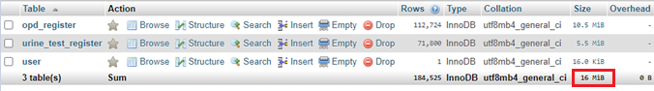

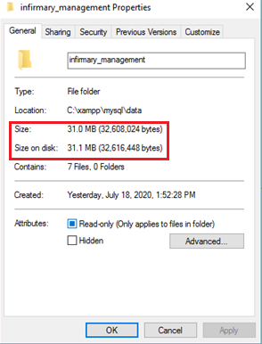

**B7: HOSTING**

To initiate the process of hosting the website I contacted the school’s system administrator via email and cc’ed the mail to my teacher and my client

|  |
| --- |
|  |

|  |
| --- |
|  |

To get permission from the school’s principal, my teacher sent a email:

|  |
| --- |
|  |

The principal responded positively and asked us to proceed with hosting. My teacher consulted with the system administrator and I sent him the code files:

|  |
| --- |
|  |